Emax-RAP- Day 10_ 01-04-2026

Implement RAP based applications:(READ only Apps)
on premise systems sales/customer/delivery- whatever the tables in on premise, these tables we can't able to see in ABAP public cloud systems.
As of now /travel related tables are available in the particular cloud system.
We can use it travel tables or custom tables we can consume it in RAP.

Create Data Definition for root entity:
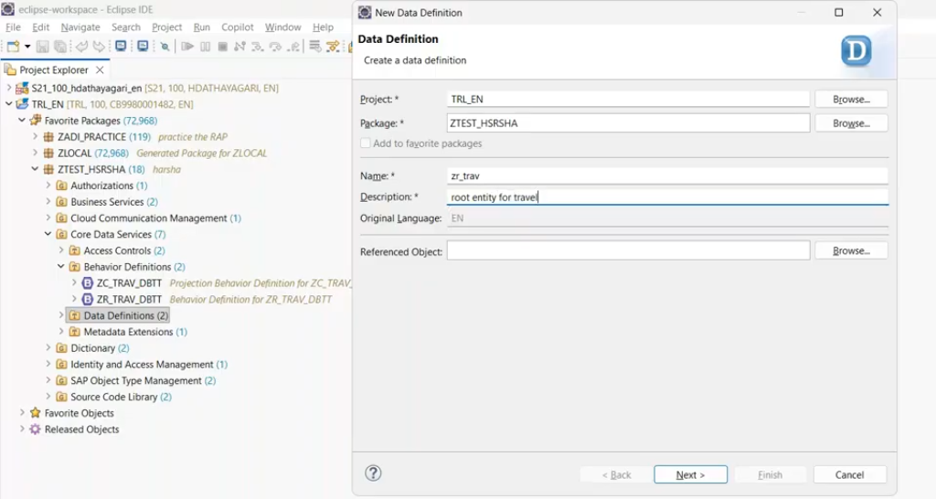
select the template called as root view entity.
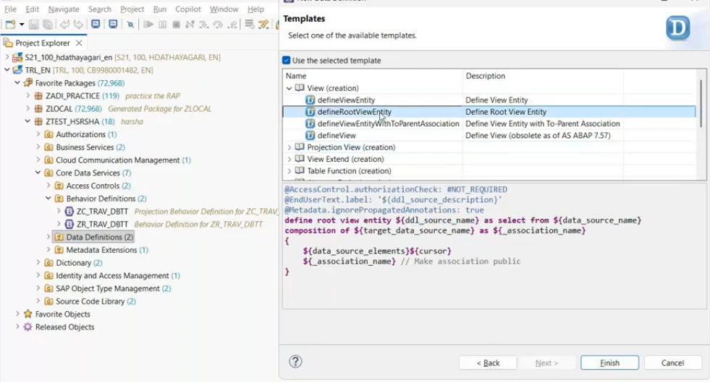
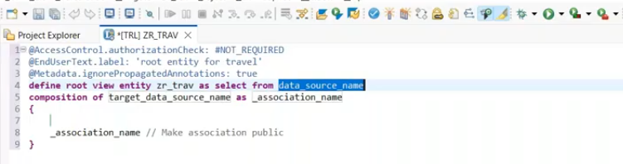
table name: /dmo/travel
18:00
ctrl + space - get all the fields from table/ source
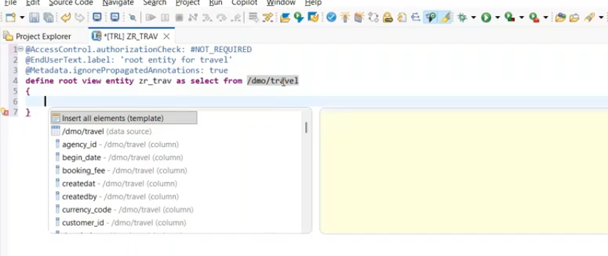
select insert all elements.
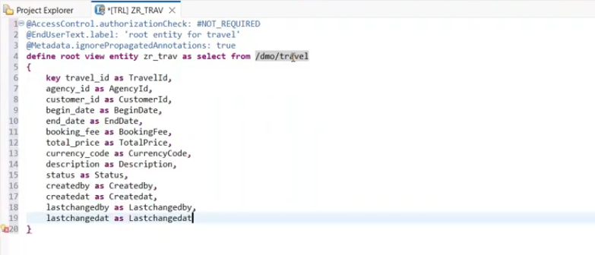
for amount- booking_fee- reference field missed, this means we have to pass currency field.
@Metadata.ignorepropagationAnnotations : false - whatever the annotations showing as error and if you want to make these information/optional, you can make it as "false".
@Metadata.ignorepropagationAnnotations : true - whatever the annotations showing as error and we need to provide the specific annotations then only these error will remove.

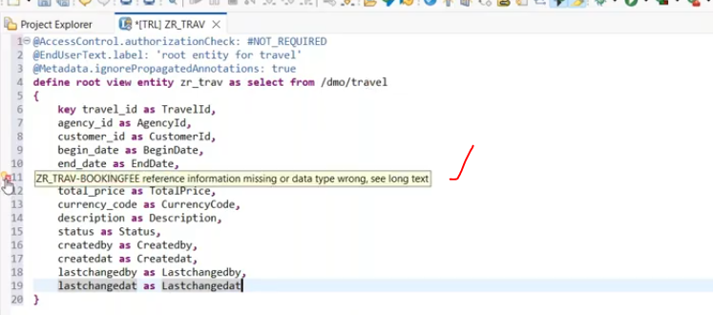
now we set the ignorepropagationannotations is "false"- No error.
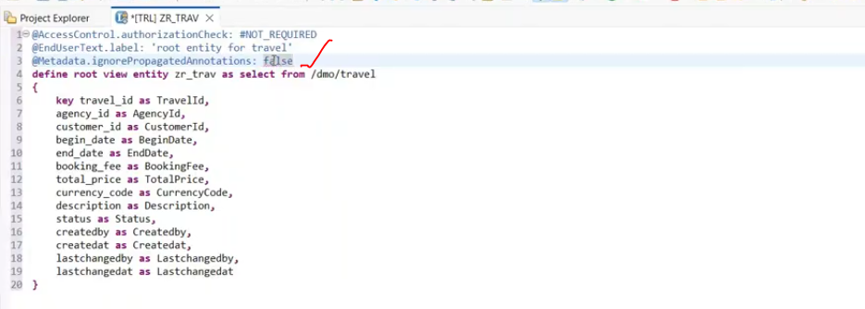
take the specific columns in the selection list.
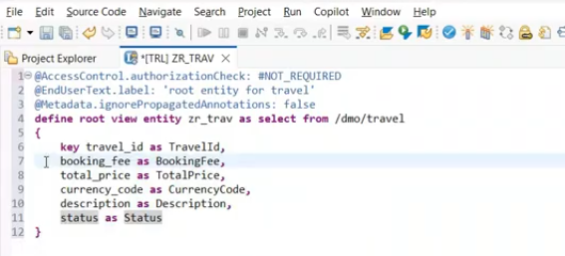
once insert all the element, alias name of the fields automatically captured.
save and activate.
output:

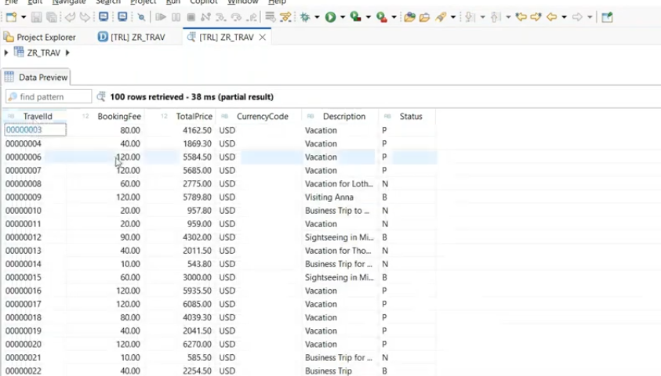
we built the data model.

Expose to the UI level: Projection View.
it is not compulsory each and every field to expose at ui level.
even if it is expose all fields to the ui level - we can hide it also.
21:00
this will be done through the projection view.
projection view will be created on top of the root view.
Create projection view.
- right click on root view - root view is zr_Trav. --> click on new data definition.
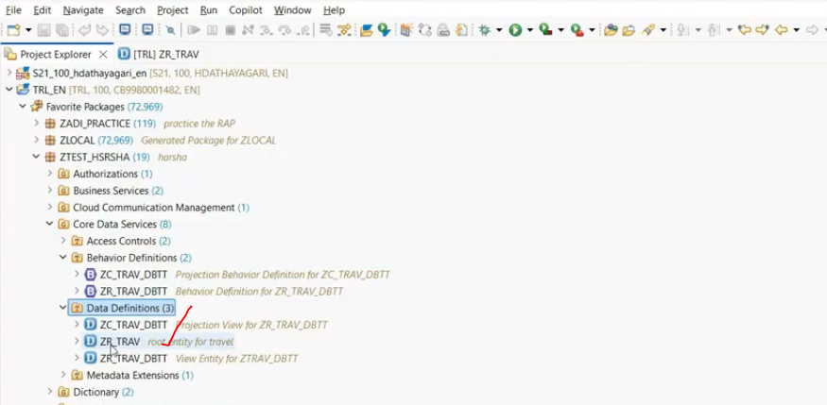
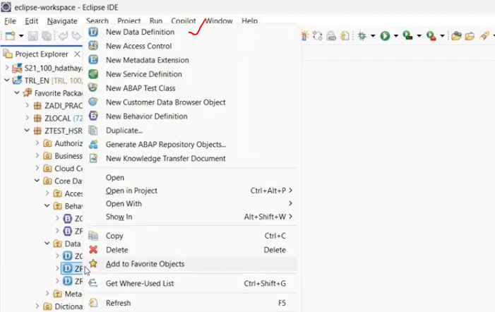
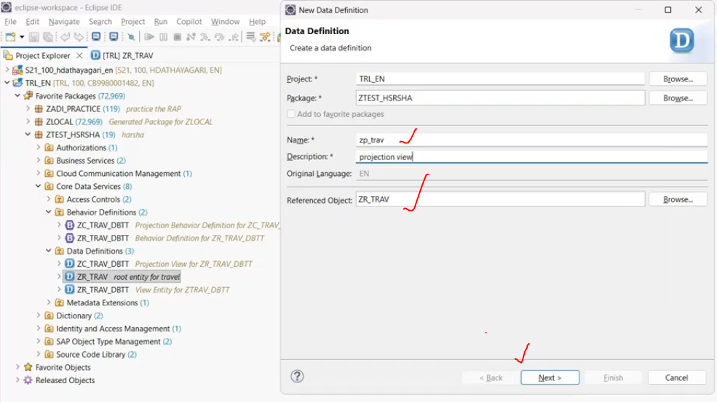
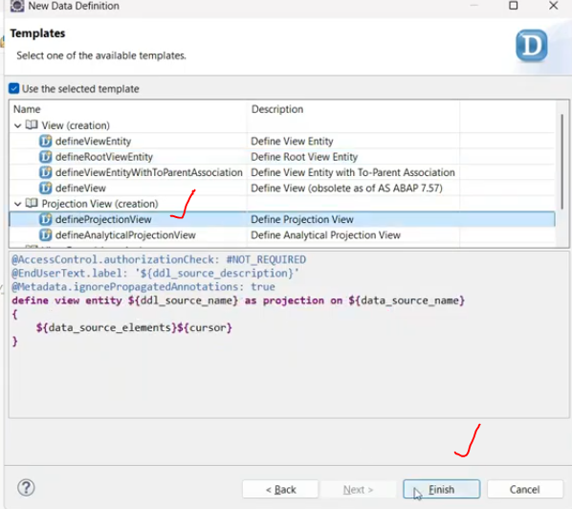
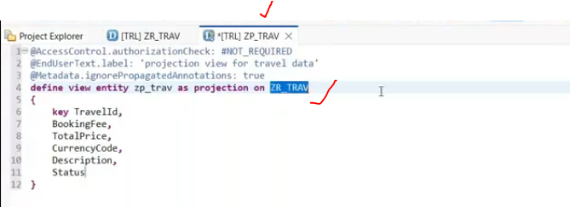
now we will receive an error
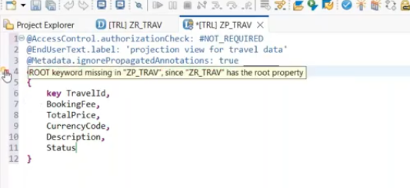
root keyword is missing- why is it giving? -we are creating projection view based on root view- means base view is having the root property, but when you trying to create the projection view/further view- it is normal view entity, it is not the root view. means normal view entity- so both are not compatible- root view and projection views.
if base view is normal view entity --> projection also normal view. --> not required root here.
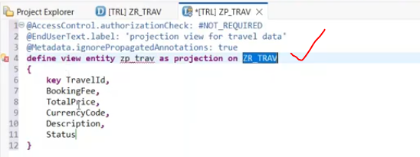
similarly, we have to add the root property to the projection view as well.
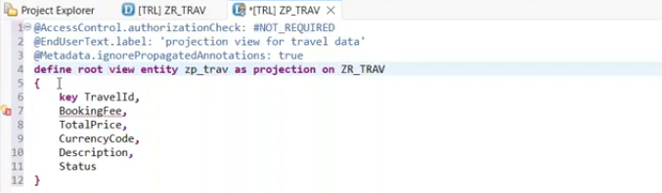
getting reference error: so we can make it as a annotation: ignorepropagatedAnnotation: false- annotations errors are ignored.
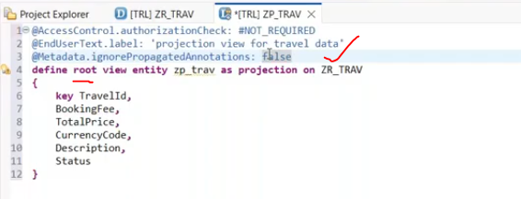
Now we can apply the whatever annotation at field level, which you have to expose to the ui level.
@UI.facet: whenever you want to see the particular set of records in the object page.
object page- next page/detail page.
type: #IDENTIFICATION_REFERENCE .
@UI.identification - referring to the object page. in the list report when you generate an fiori app, there is a two kinds of pages are there-
1. list report(Main page)- if you want one set of a columns should be automatically coming without any manual selection- you have to use @UI.lineitem .
2. if i want to see the particular record in detail of the base record- once click on base record it will navigate to next page. next page means object page- if you want to see any particular base record - detail information in the object page, you have to apply @UI.identification.- this will identify only when you apply the @UI.facet and type as "IDENTIFICATION_REFERENCE".
@UI.lineItem whenever you want column should be automatically replicated without any manual selection-
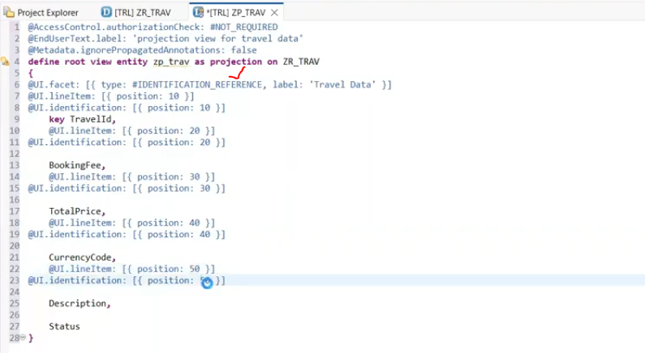
@metadata.ignorepropagationAnnotations: true/false
1. true: default value- mens - some of the annotation need to provide as mandatory, like provide annotation reference variable for amount field.
it is making the reference information as mandatory
2. false- if we make it as a false, that error( reference information errors) will make it as a optional.
29:00
Once you build the data model, you have to build the data service.

Business Service: Service Definition
in this business service, which entity you have to exposed into the ui level.
in projection view, we defined the how my fiori app. you have to expose the projection view entity into the service definition-- this entity exposed into the UI/odata level.
- right click on projection view -->select the new service definition.
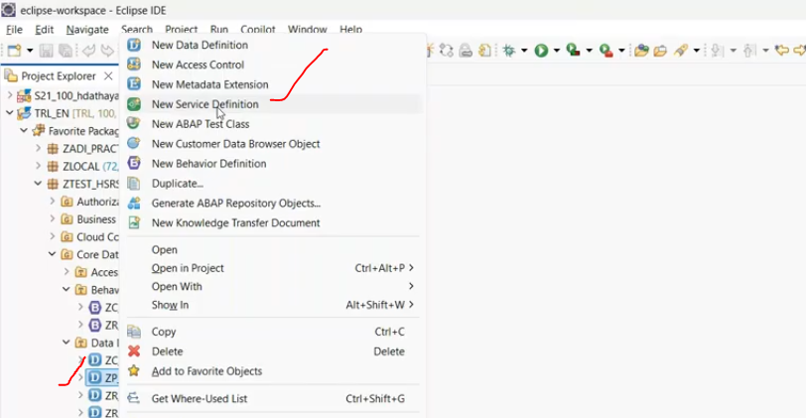
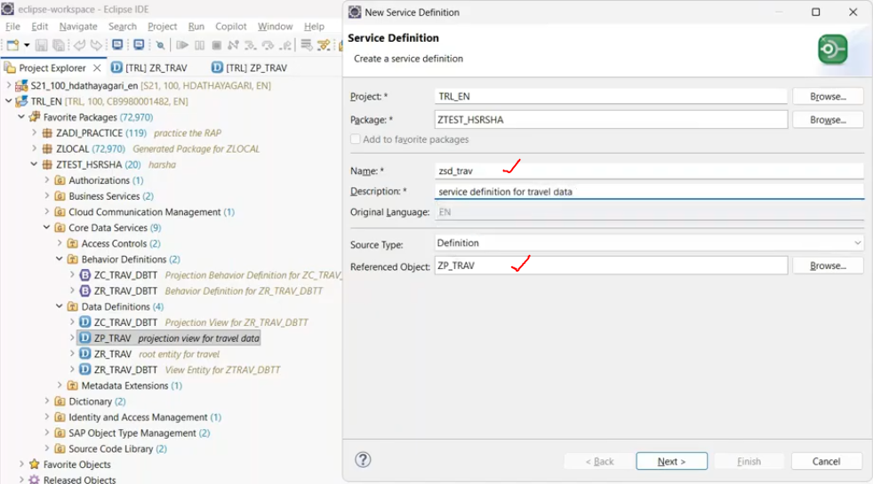
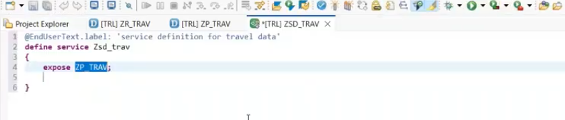
automatically your projection view will be exposed here,
maintain the alias name for projection view.
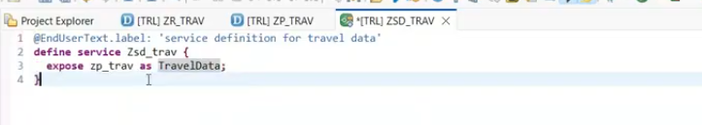
once you build the service definition, you can able to see
data model -->Projection View -->service definition -->service binding
service binding created based on service definition.

Service Binding:
right click on service defintion(ZSD_TRAV) -- click on service binding.
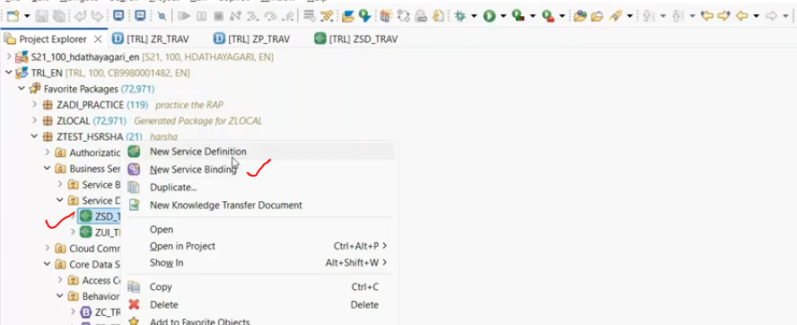
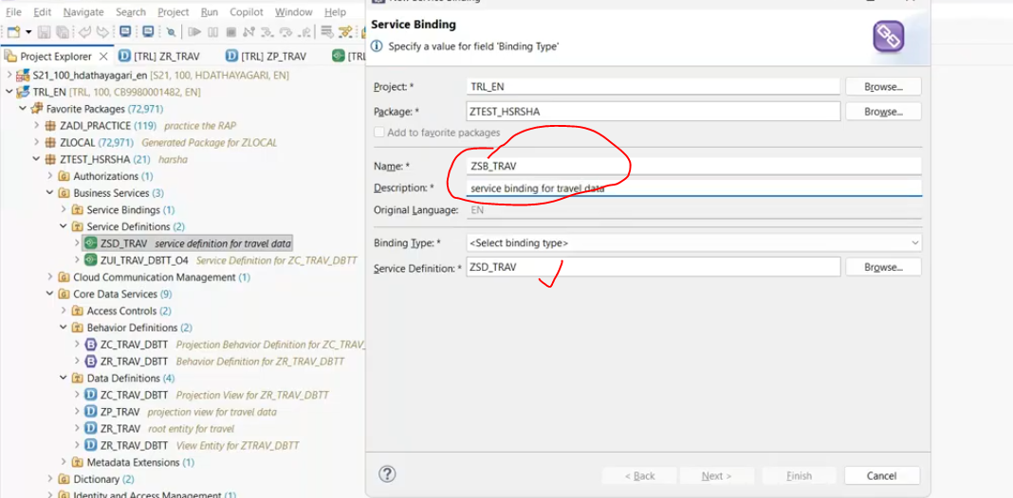
Binding type :
Odata V2 UI- generate Odata V2 UI(Odata+FIORI App)
OData V4 UI- Generate Odata V4 Ui(Odata+FIORI App)
Odata V2 web api- generates only odata service,
Odata V4 web api- generates only odata service,

Odata V2- if you are using the implementation type managed without draft and you want to use the fiori elements- you use Odata V2.
Odata V4- if you are using the implementation type managed with draft and you want to use the fiori elements- you use Odata V4, sap strongly recommended.
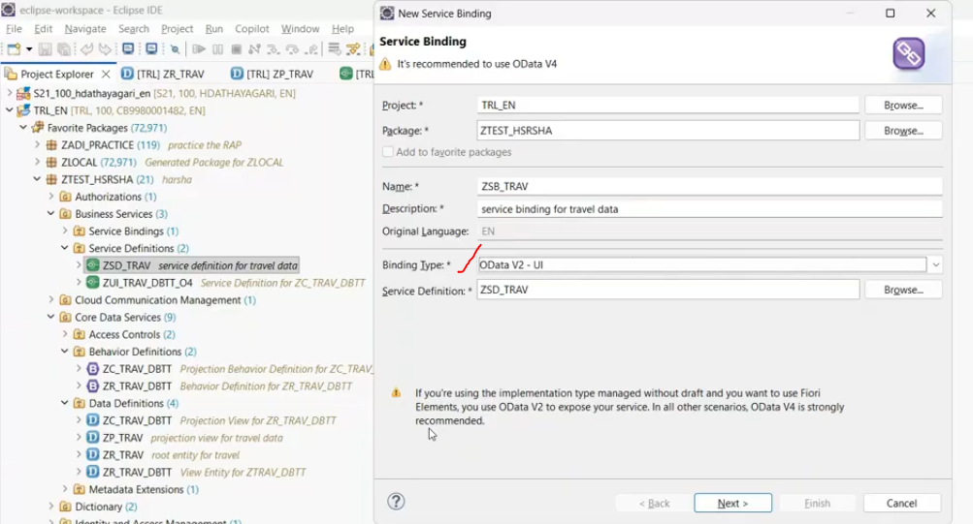
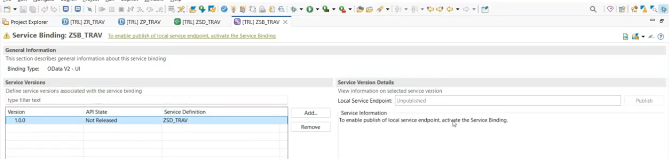
now publish the service.
By default publish- button not enabled. to enable this "Publish" button, save this and activate the service binding - now publish button enabled.
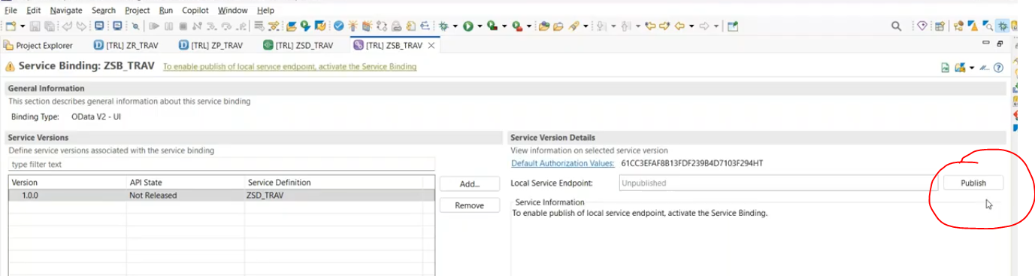
click on publish -->
if it is Odata V4- binding type -in ABAP on cloud we don't have any problem to register. while coming to on premise system for OData V4 - we will face the publishing issues.
for odata V4 service- we have to register with the tcode-/iwfnd/v4_Admin
for v2 automatically published.
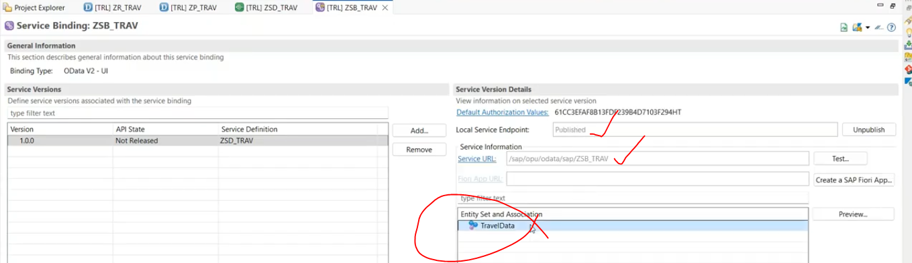
V2 published properly.
V2- path-/sap/opu/odata/sap/<service>

Test Your API- Odata:
click on service url:
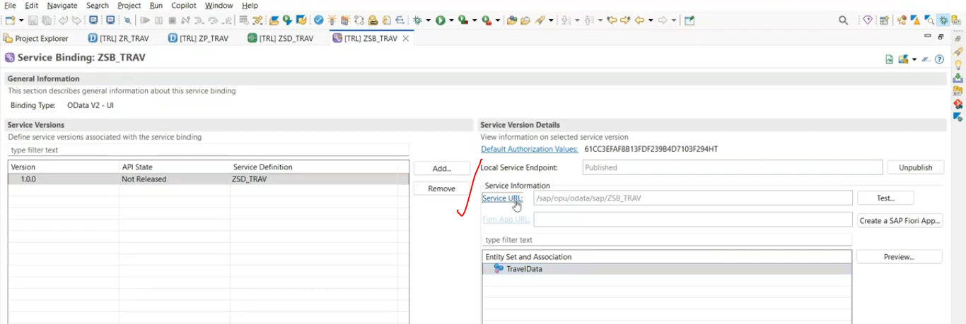
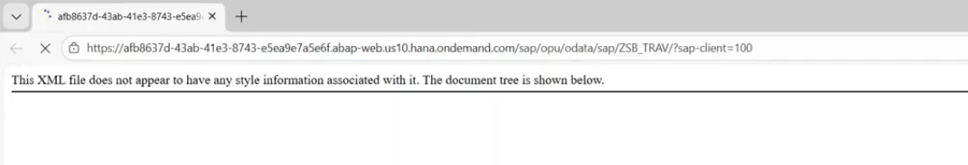
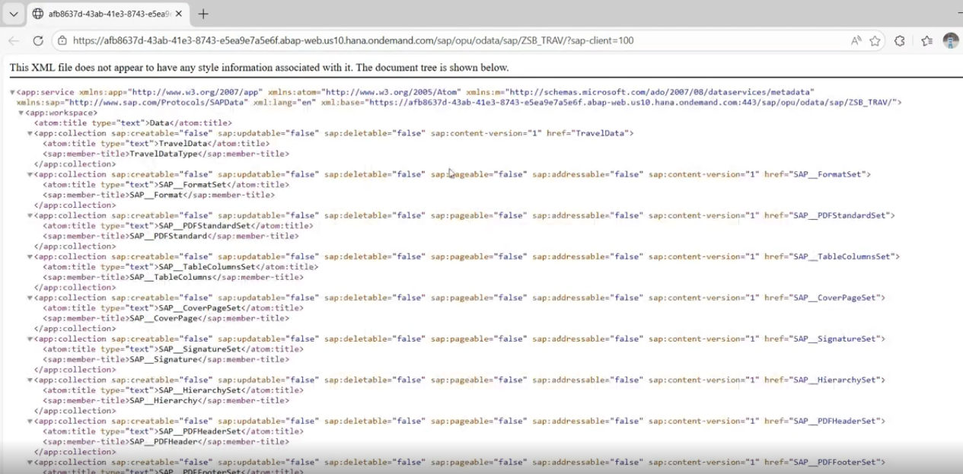
$metadata:
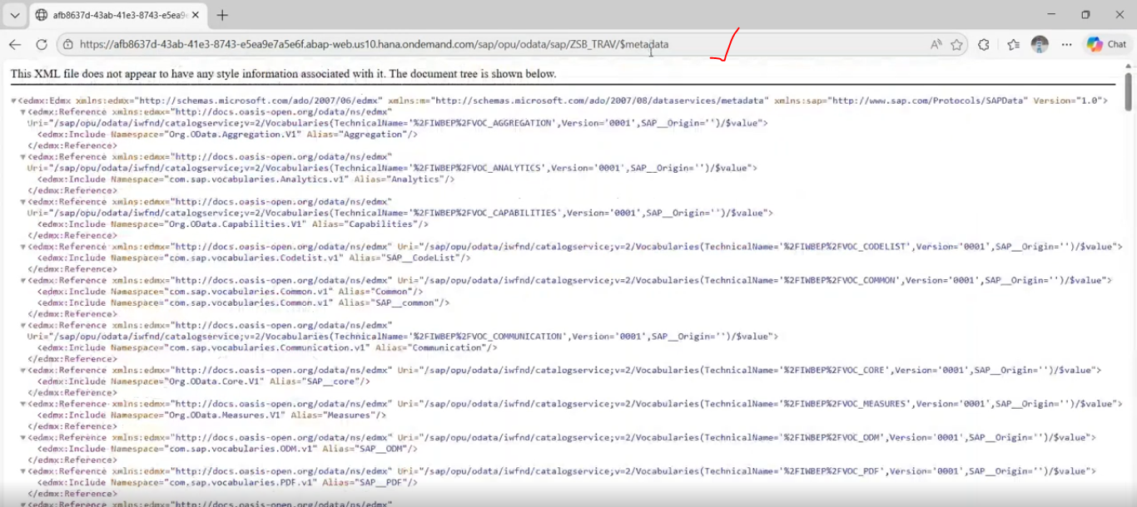
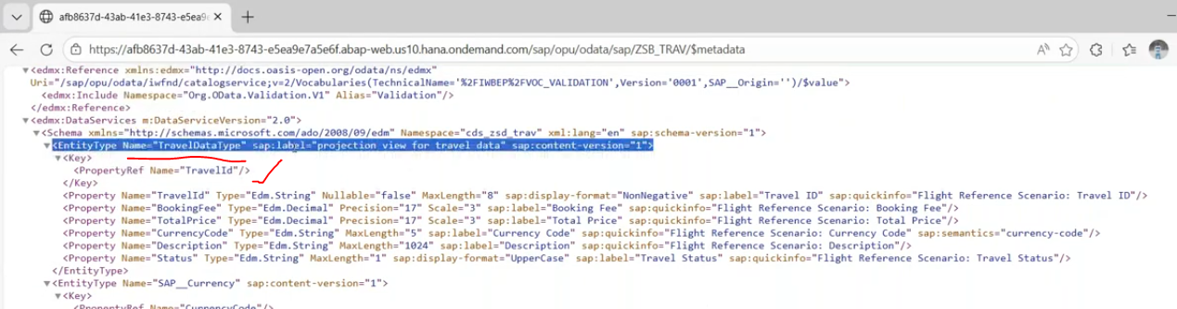
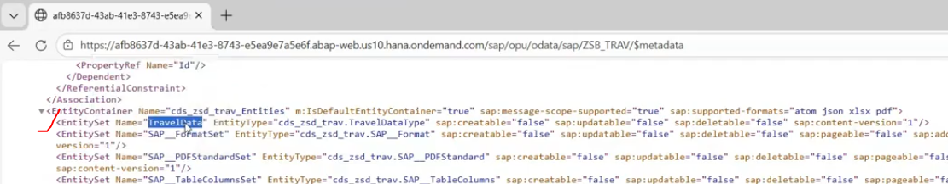
entity set: TravelData.--> get the data from root entity.
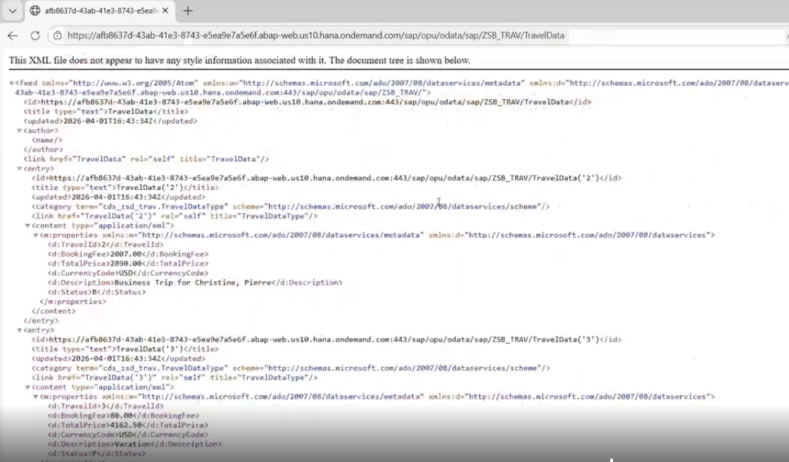
42:00
for single record- TravelId = 2.
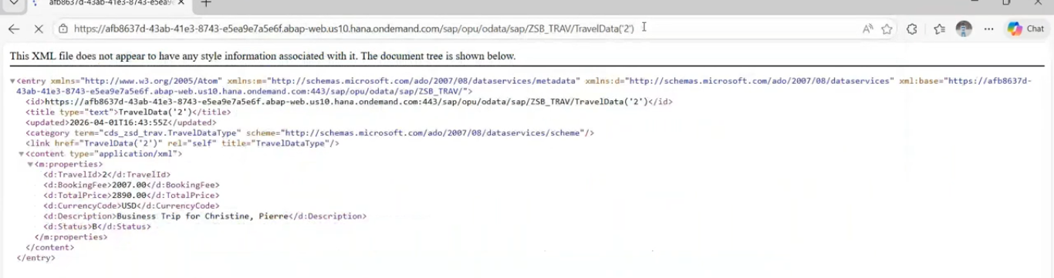
json format:
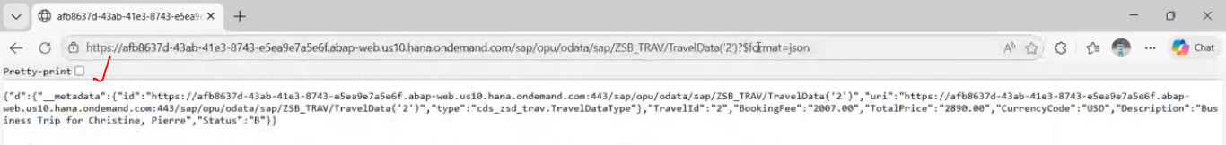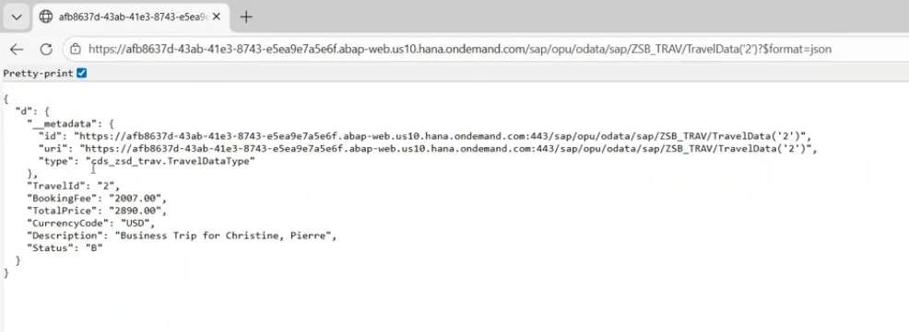

Test With App:
if you want to check the data with app.
select the entity set and click on preview in service binding.
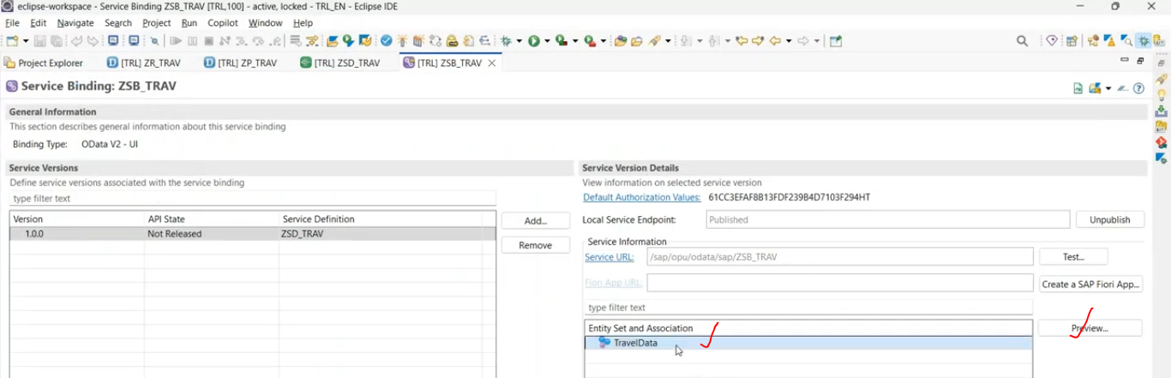
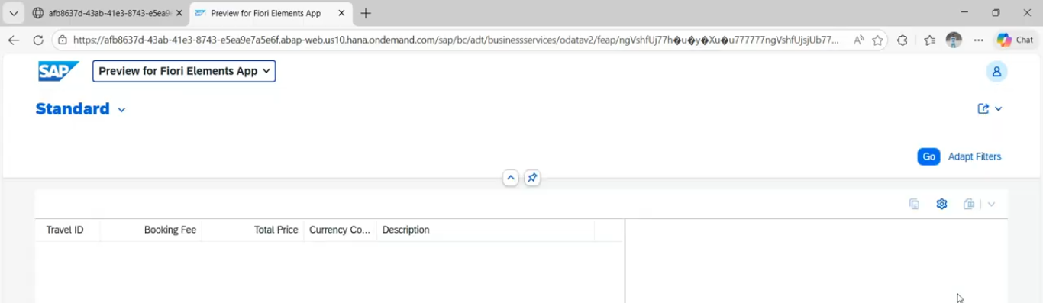
Whatever the coulmns are applied those columns are coming here( @UI.lineitem.

add few more columns in the list -->select the filters(settings button)-->select the travel_Status
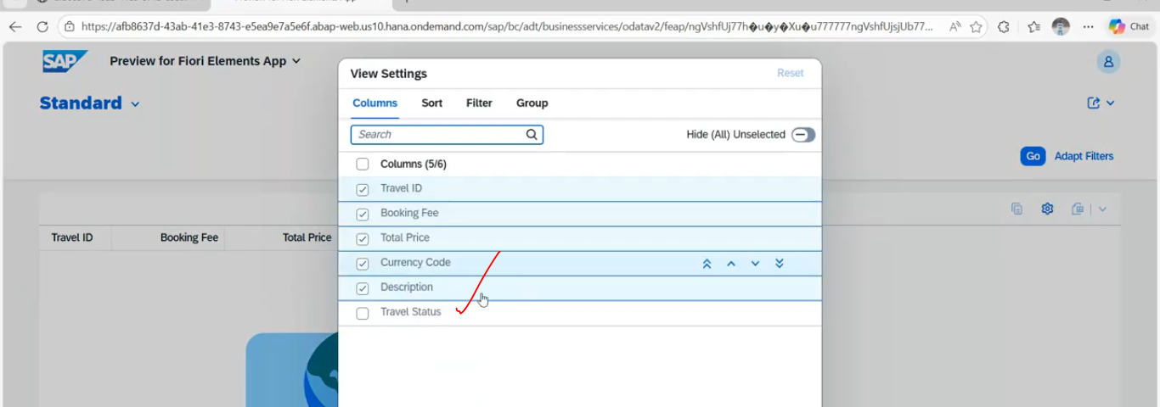
click on go --> data displayed in list.
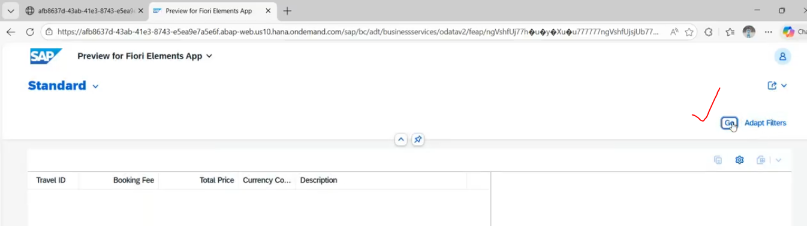

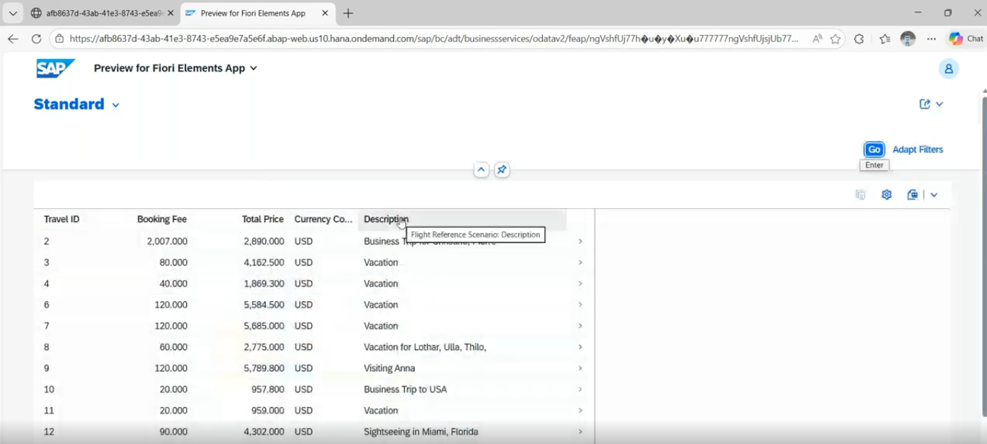
if you select any record --> it is navigating to the detail page/next page.-->@UI.Identification.
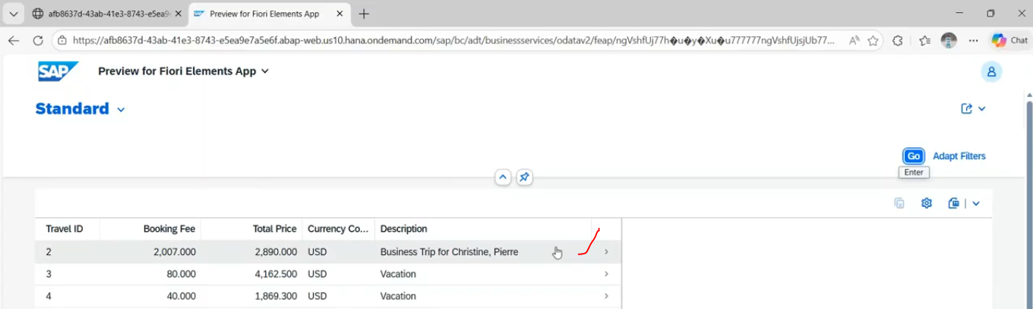
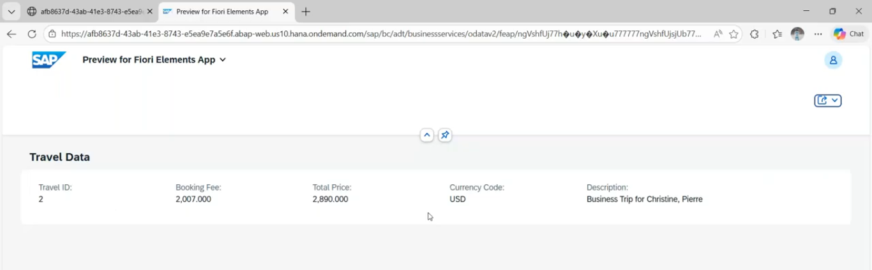
This is read only application.

List report has the predefined functions are there:
Download data in excel :
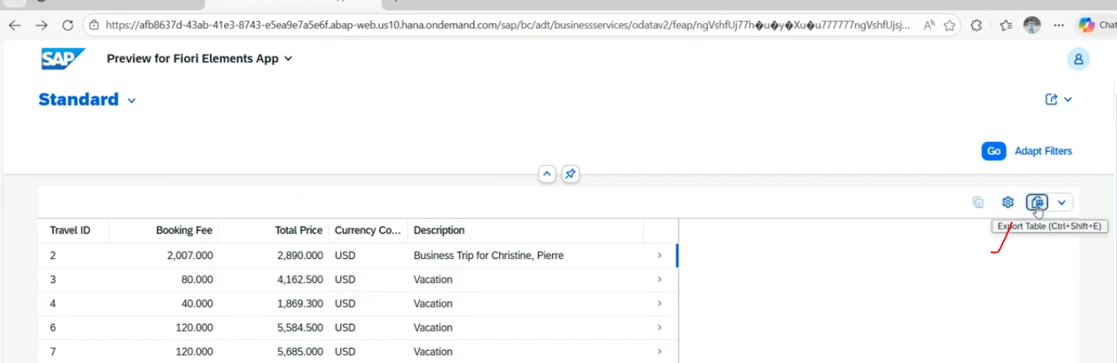
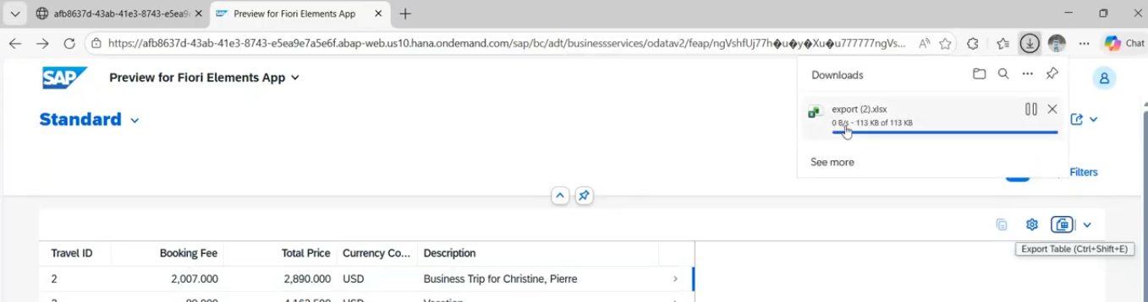
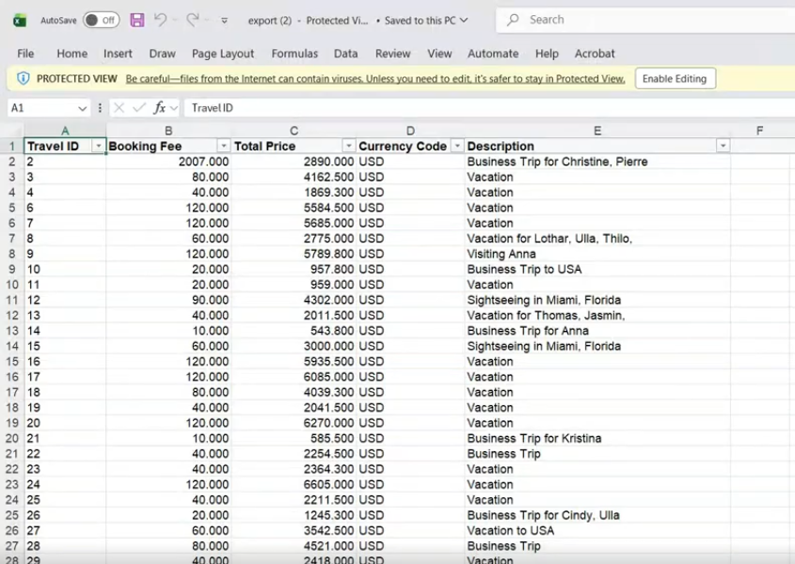
Filter/SORT/Group By
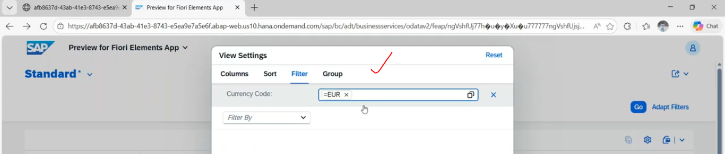
50:00

